1. Created a Vnet1.

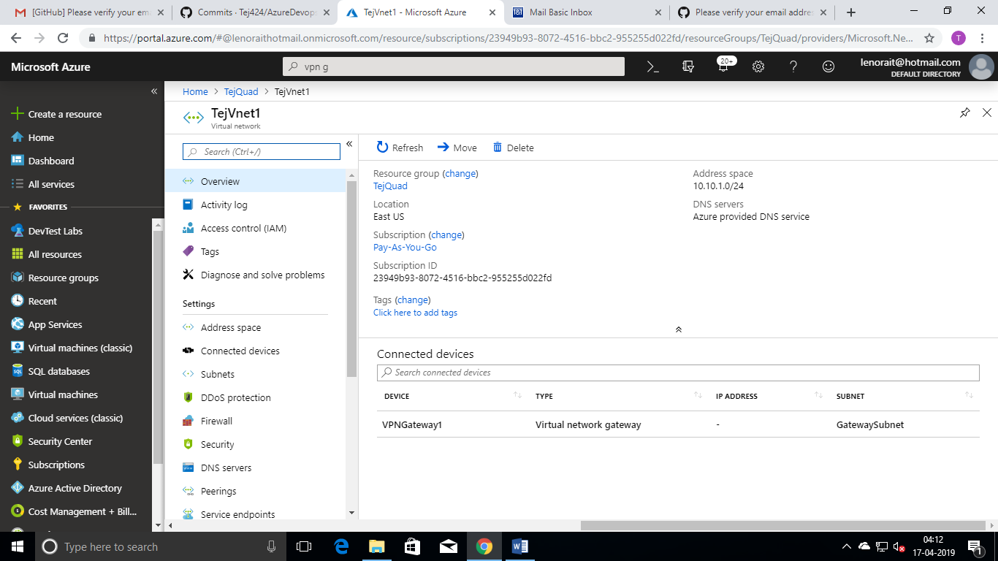

1. Created a 2 Subnets and 1 Gateway Subnet for Vnet1

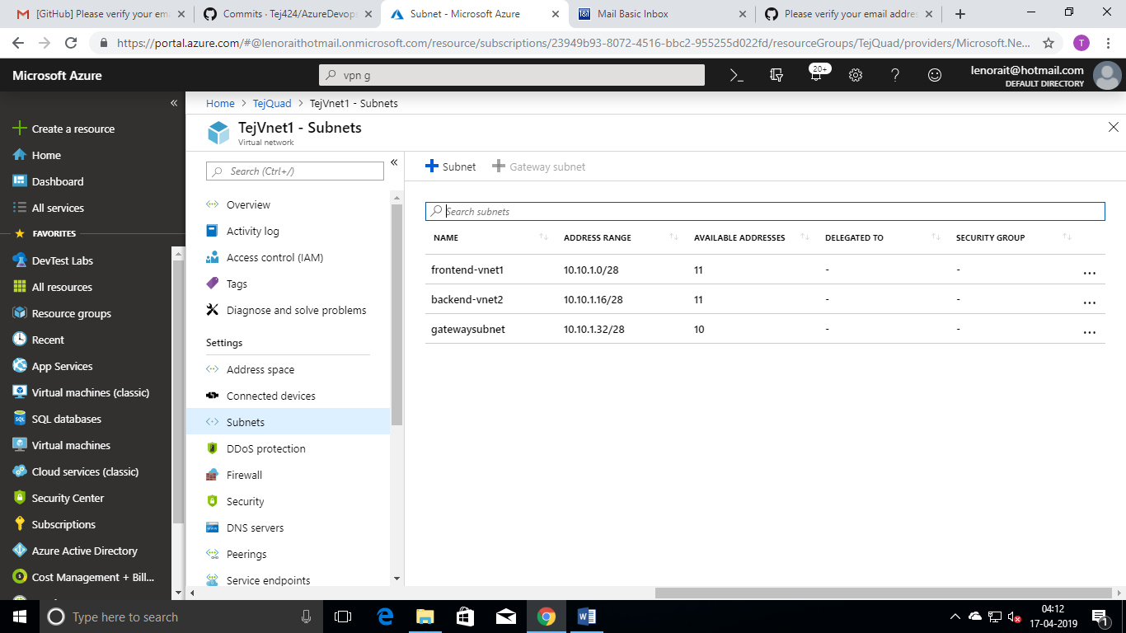

1. Created a Vnet2

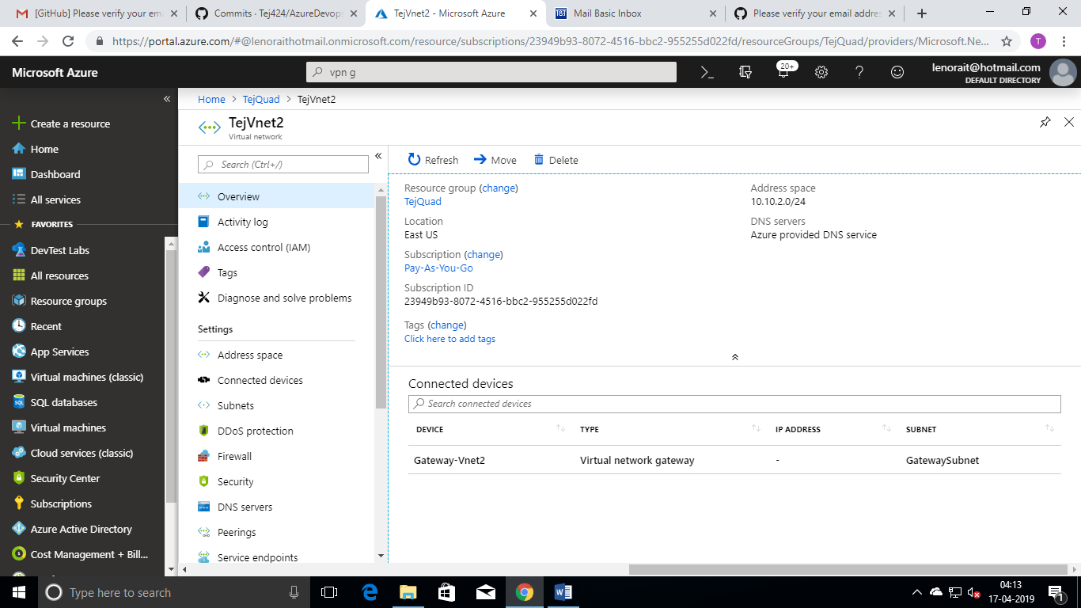

1. Created a 2 Subnets and 1 Gateway Subnet for Vnet2.

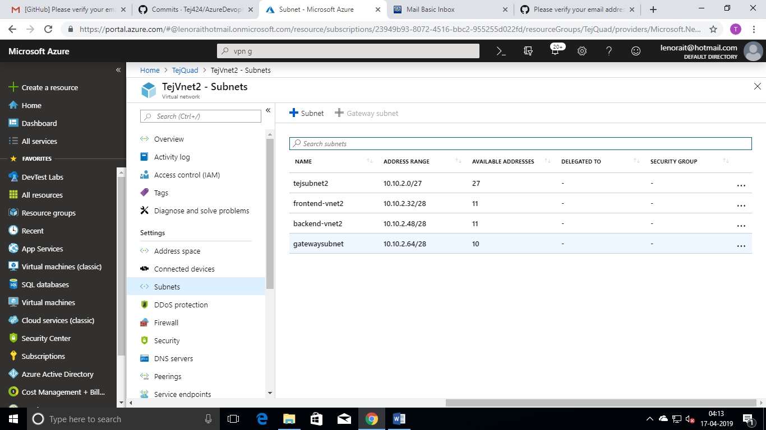

1. Created a Vnet3.

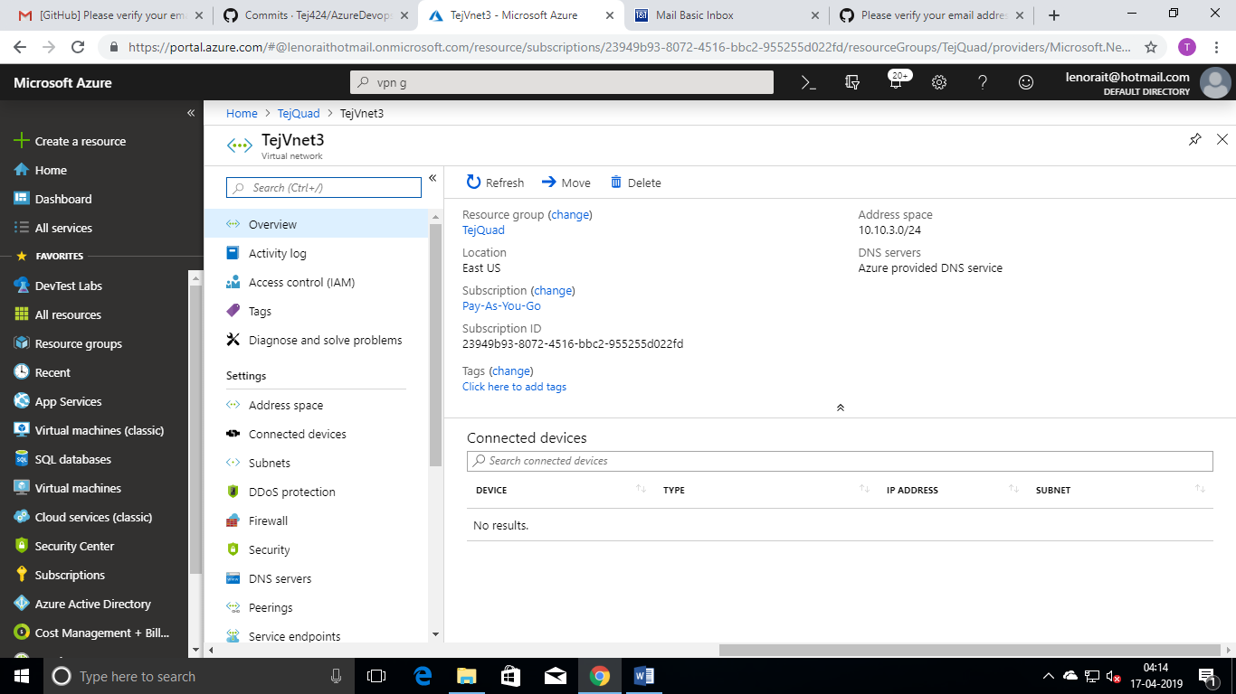

1. Created a 2 Subnets and 1 Gateway Subnet for Vnet3

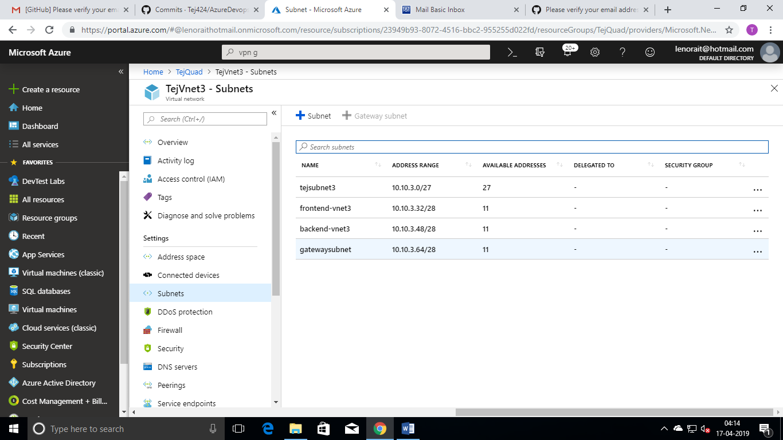

1. Created a VPN Gateway1 for VNet1.

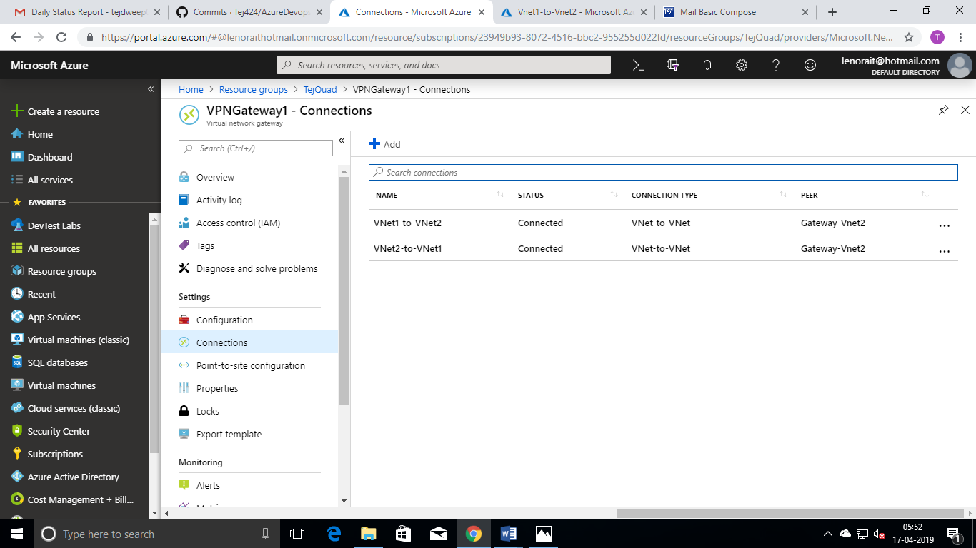

1. Created a VPN Gateway2 for VNet2.

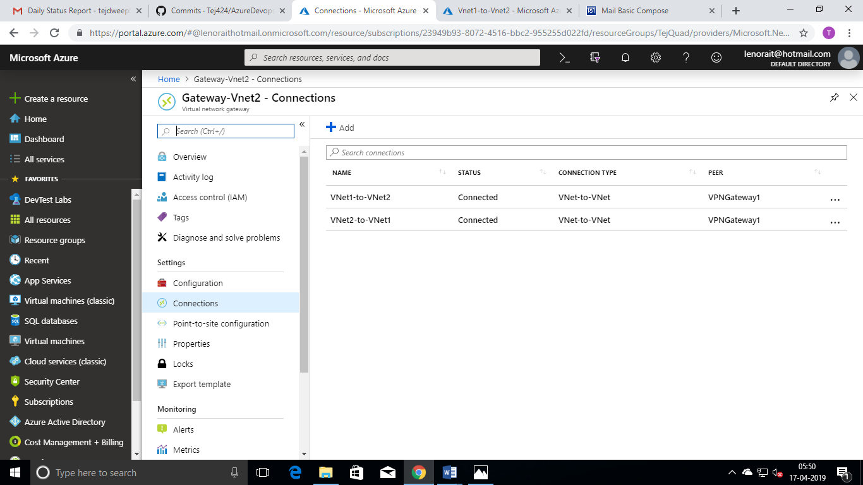

1. Created a VPN Peering for VNet2.

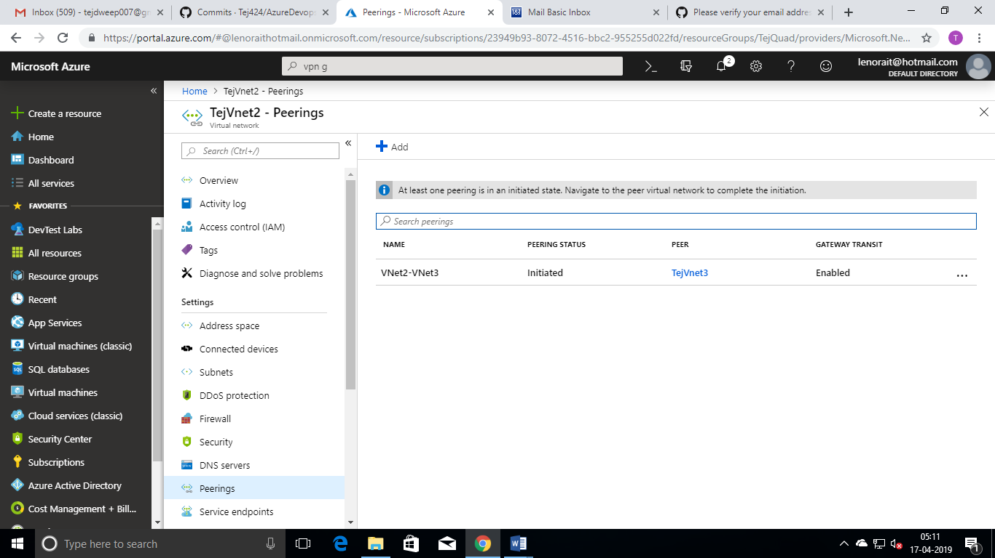

1. Created a VNet Peering for VNet3.

